# How to run a python app on AWS ?

Based on great work of UrmaGurd (Urmadealgenie on github) : <https://github.com/UrmaGurd/UrmaDealGenie>

Sorry if pictures are in french, I did not find how to put the AWS in english (usualy, it’s the opposite !).

Disclaimer : The goal of this doc is to provide a starting point to help you make an informed choice. The information on an "as-is" basis and makes no warranties regarding any information on or through it, and disclaims liability for damages resulting from using the license information. If you have any questions regarding that doc or any other issues relating to it, it’s always best to consult with a professional. Further more You must use that in PAPER mode for testing and learning use. I can’t garanty anything about security.

In summary, to run a python app on AWS (AMAZON WEB SERVICES), you must :

1. Create a [new account in AWS (free)](https://aws.amazon.com/free/)
2. Create an Amazon Elastic File System (EFS) and then create an instance (=server) EC2 Linux server 2
3. Open connection between Linux Server and your computer (CMD)
4. Upload files from TB’s release:
5. Run on Linux’s server the python’s app

And that's it. Detailed steps below.

**1. Create an AWS Account**

Amazon Web Services (AWS) has a free tier that allows several services to run free of charge. One of those free services is "Lambda functions". These are serverless functions that allow code to run in the cloud in your own AWS account, without being logged in or needing a PC running 24/7.

1. Go to [AWS Free Tier](https://aws.amazon.com/free/) and sign up
2. You will need a credit card, but this is to prevent fraud and bots (see [AWS Free Tier FAQs](https://aws.amazon.com/free/registration-faqs/) )
3. Make sure you secure your account with 2FA

Also make sure you [complete account creation/verification](https://stackoverflow.com/a/60024362/370692), otherwise you'll get an error when deploying the 3cqsbot app.

**2. Create an EC2 Linux 2 Server**

This server will run your app in the cloud (no need to have your computer runing night and day !).

Follow this guide : <https://docs.aws.amazon.com/efs/latest/ug/whatisefs.html>

1. Create your Amazon EFS <https://console.aws.amazon.com/efs>
2. Create an instance EC2 <https://console.aws.amazon.com/ec2/>
3. Choose Amazon Linux 2 Kernel 5.0 
4. Choose the free instance : 
5. Check and lauch as it (no special option to choose)
6. After a few minutes you get this instance runing : 

**3. Open connection between Linux Server and your computer (CMD)**

For that, you must choose your instance and click « connect » :



You get there :

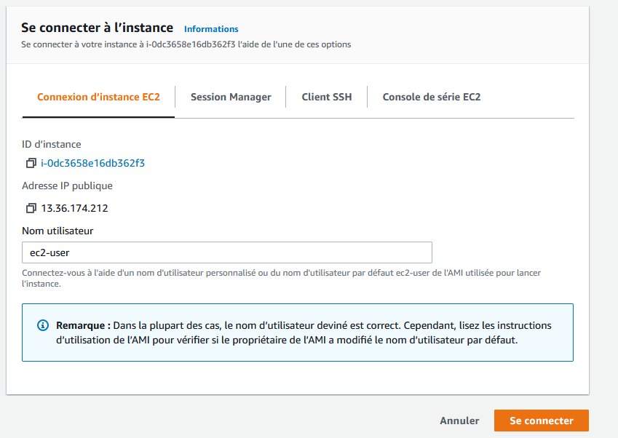

And you click connect. A window will open, as a command :

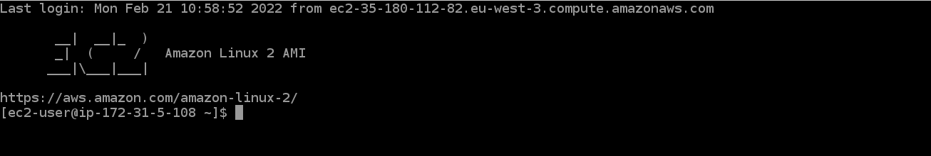

It’s your Linux server ! It is Python3 ready but you’ll need to install on it :

• py3cw module (write « pip3 install py3cw »)

• telethon module (write « pip3 install telethon »)

**4. Upload files from TB’s release**

First upload files from TB’s github

<https://github.com/TBMoonwalker/3cqsbot.git>

Put them in a directory on your Users root (easier to download thme on your Linux server). For exemple /Users/JFB/3CQS in my case.

You must now connect your computer with the Linux Server. For that, use AWS connect (SSH one) :

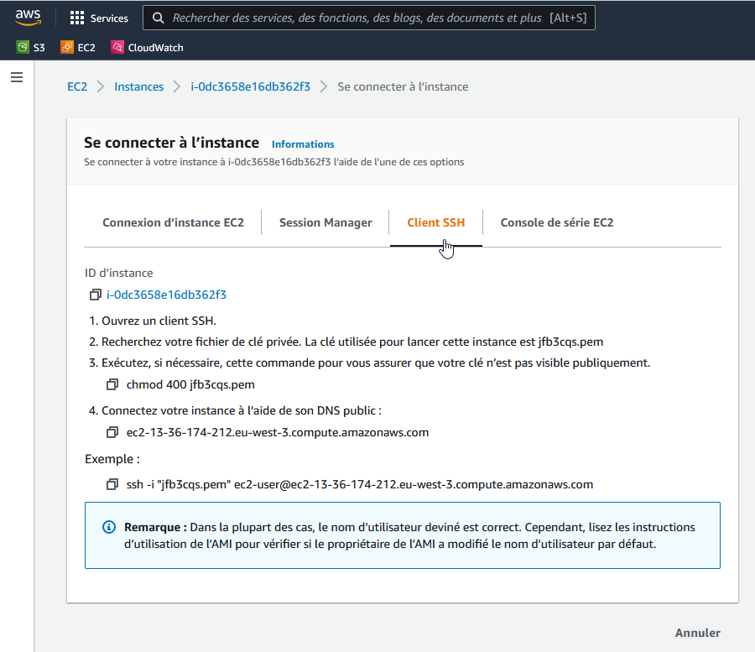

Normaly SSH is on your computer. You go in CMD and paste : 

Where « jfb3cqs.pem » is your private key created when EC2 was created. Your pem key must be in the root of your /Users/JFB.

You get this :

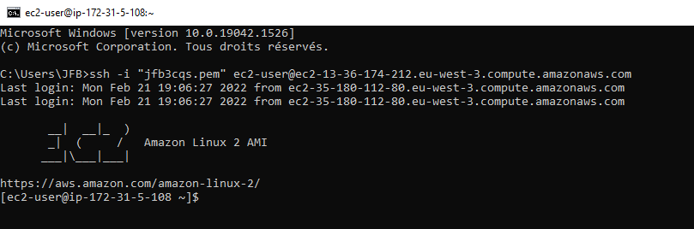

You are connected with your Linux server.

We will now upload to the server the files needed by 3cqsbot :

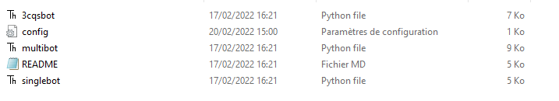

Don’t forget to edit config.ini as exposed by TB’s on Github.

Then, we use the scp command :

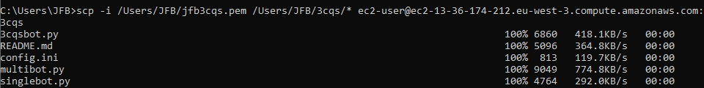

Where :

* /Users/JFB/jfb3cqs.pem is your private access key to Linux’s server
* /Users/JFB/3cqs/ is where are the files to upload (don’t forget * to upload all of them)
* Ec2-user@ec2... Is the public IPV4 adress of your Linux Server

1. **Run on Linux’s server the python’s app**

Ok, files are on the server. You can now close the local CMD windows and come back to the Linux Server CMD window :

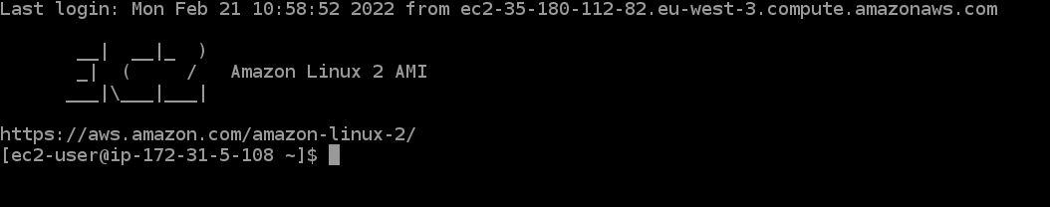

You must in the directory where are the files, write : cd 3cqs

Then to see if file are present, write : ls

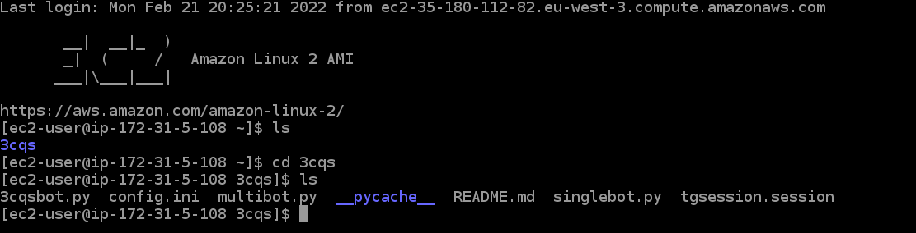

Ok, now we can lauch the python’s app : python3 3cqsbot.py

And it’s working :

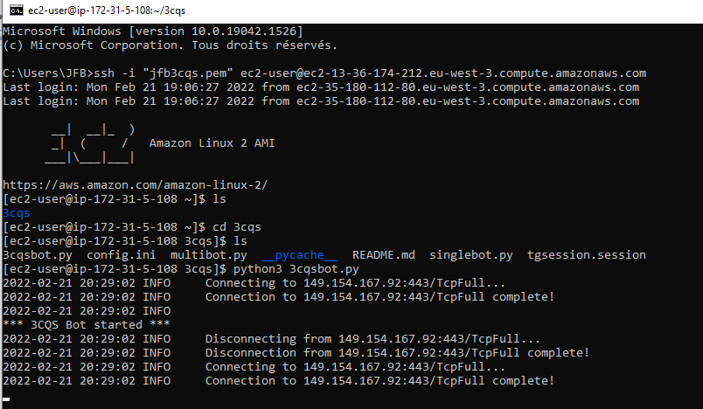

**Monitoring**

This is how you can see if your Linux server is running. Go to EC2, shoose your instance. Press :

**Dashboard**

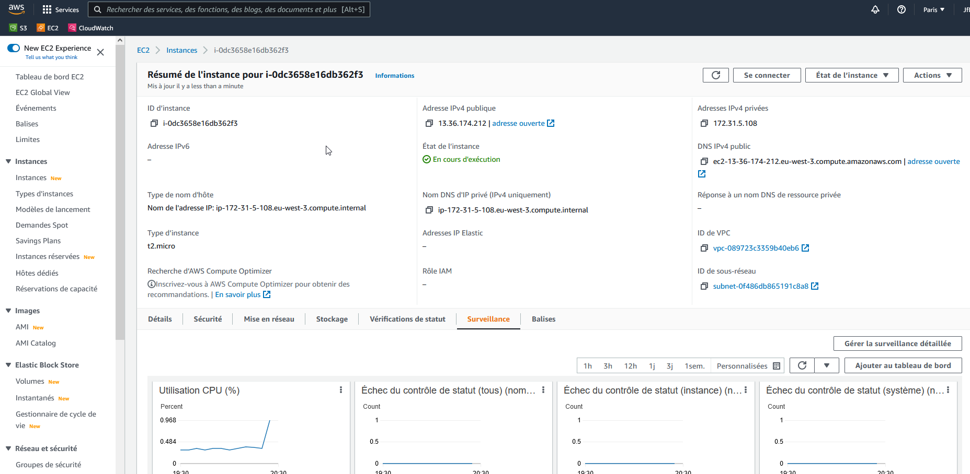

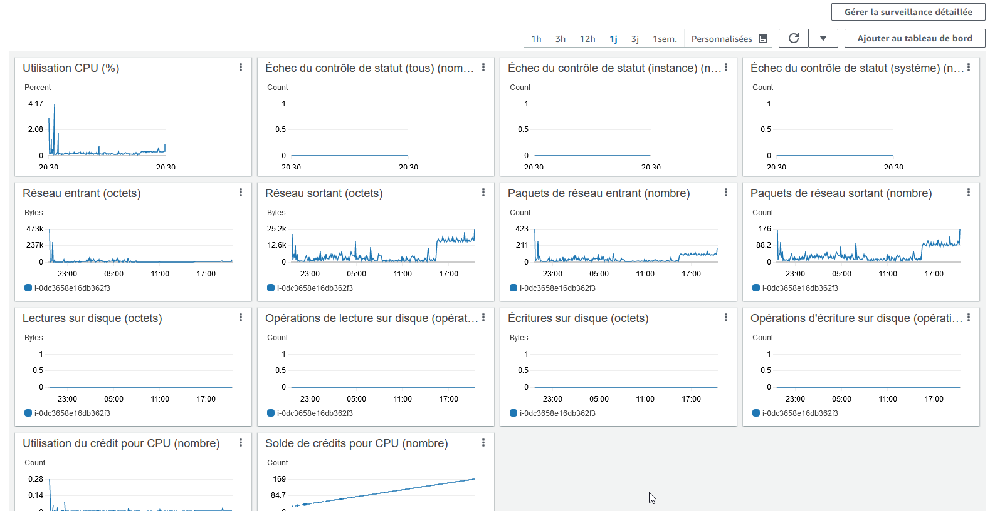

I expect, it’ll help.